How to log-in and complete the 3 sections of your DofE

In order to log-in you will first need your username and password. If you don’t have these, you need to contact Mr Brown or Mr Hawkins. Your initial password will be your 8 digit DOB eg: 14/09/2022 becomes password 14092022.

You then need to go onto edofe.org and enter your username and password.

Once you have done this you need to enter all your personal details, address etc. Any field marked with a red asterix needs to be filled in. Once you have done this press ‘save’. If all your details have been filled in correctly this will then generate an e-mail to DofE and your ‘Welcome Packs’ will be sent out directly to the address you entered onto the system.

Using the points listed below you can now enter the details for the 3 sections. The assessor for each of the sections cannot have the same surname as you and must be over 18 years old.

- Remember 1 of the sections has to be completed over 6 months whilst the other 2 are for 3 months.

- If any of the 4 sections say ‘draft’ at the top of the page then all parts marked with an * must be filled in. You need to ensure that your ‘goals’ section is completed in as much detail as possible as this is the main part and the section will only be approved if there is enough detail in here. Once they have ALL been completed a box will open which asks you to choose a leader to approve the section. The only option it gives you is Mr Brown.

- Whilst it is not essential as the main piece of evidence required to pass each section is the ‘Assessors Report’ it is good practice to upload further evidence such as photos as extra evidence.

- Once you have completed either 3 or 6 months you need to get your Assessor to complete the ‘Assessors Report’. They need to ensure that all key parts are completed correctly in line with the details you entered at the start of the section:

  - Activity
  - Date started / Completed. These must be the same as the start date and timescale as stated when you entered the section details and the completed date must fit in the timescale of the section be it 3 or 6 months.
  - Goals set by participant
  - Assessors personal details

- This then needs to be uploaded to EDofE by either scanning it or taking a photo and uploading using the guidance via the ‘upload evidence’ tab.
- Once you have uploaded the ‘Assessors Report’ and any other evidence an alert will be sent to Mr Brown and and if he is happy with your evidence he will approve the section.

How to enter the details for the 3 sections onto EDofE

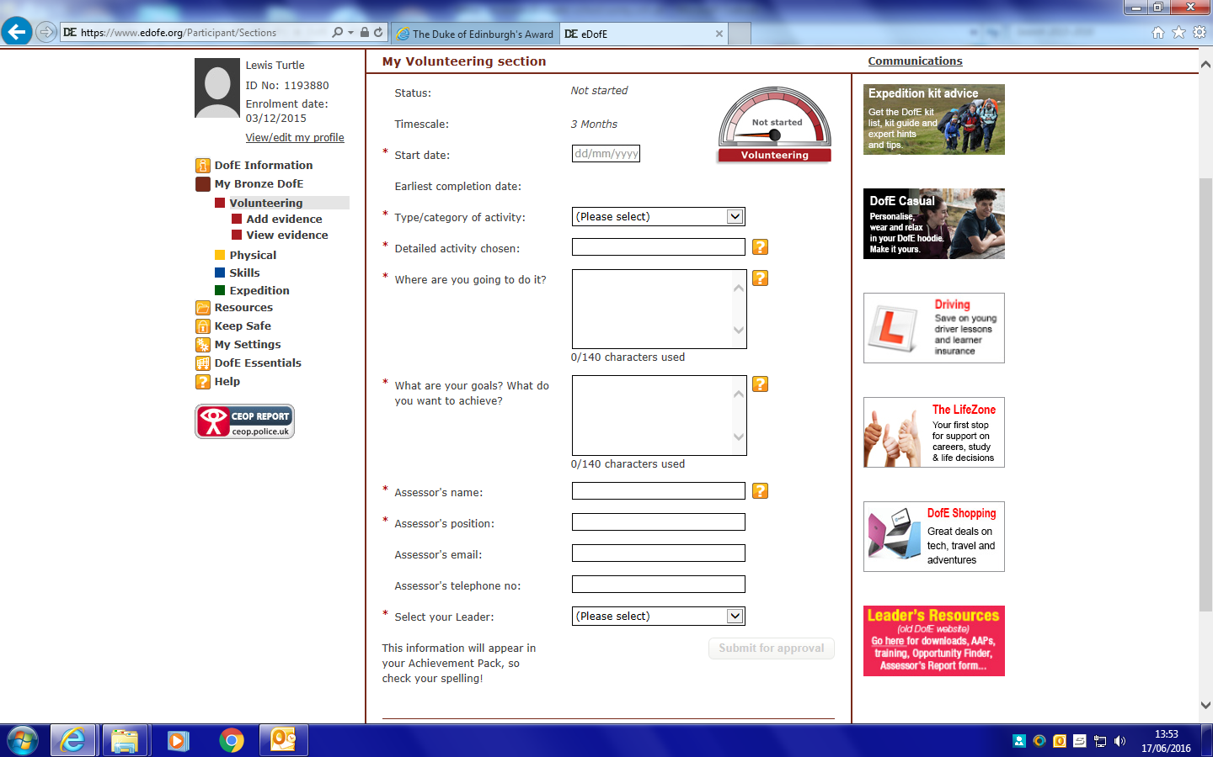

To complete each of the sections you need to enter all parts marked with the red *. Once all the details have been entered the box marked ’Submit for approval’ will open. Click on this and if all the details are fine your DofE leader will approve the section. Remember to put in as much detail as possible especially in the ‘What are your goals? What do you want to achieve?’ section.

You can also upload information, assessor reports and other evidence using the DofE App or load up edofe.org on your phones and upload pictures of your evidence / assessor reports straight to your EDofE account.

