Reigate School

PSHE (Lifeskills) Policy

Approved by: | Reigate School  Full Governing Board | Date: 30 November 2022
Last reviewed on: | 21st October 2022
Next review due by: | Oct 2023

1. Aims
Personal, social, health and economic (PSHE) education is a non-statutory but important and necessary part of all pupils’ education (Department for Education, 2020).

At Reigate School we have high expectations of our children and strive to ensure that every child achieves academically, socially and personally through our school ethos and values of Kindness, Friendship, Resilience, Curiosity and Respect.

Our PSHE programme (called ‘Lifeskills’ in the school curriculum), is rooted in our school values and aims to equip each child with a sound understanding of risk and the knowledge and skills required to safely and successfully make informed decisions that will aid them in navigating their way through life whilst at school and for the years that follow.

We recognise that PSHE can encompass many areas of study and so our programme draws on the statutory content already outlined in the national curriculum, the basic school curriculum and in statutory guidance on: drug education, financial education, relationship and sex education (RSE) and the importance of physical activity and diet for a healthy lifestyle.

We continue to tailor our PSHE programme to best reflect the needs of our current children at Reigate school through:
- Promoting their spiritual, moral, cultural, mental and physical development
- Preparing them for the opportunities, responsibilities and experiences of later life.
(Education Act 2002/ Academies Act 2010)
- The use of student and parent/carer voice

The teaching of PSHE supports our school community values of Respect, Friendship, Resilience, Curiosity and Kindness.

2. Statutory requirements
Despite PSHE being a non-statutory subject, to support all of our young people to stay safe and prepare for life in modern Britain, there are aspects of it we are required to teach. Upon statutory guidance that came into effect from September 2020, and in line with the Education and Inspections Act 2006 that places a duty on Governing Bodies ‘to promote the wellbeing of pupils at the school’, we have revised the following curriculum subjects:
- Relationships and sex education (RSE)
- Health education

Both of these statutory elements fall under the Children and Social Work Act 2017, in line with the terms set out in statutory guidance. You can access our RSE Policy here which details a parent/carer’s right to withdraw their child from certain aspects of RSE which do not form part of the science national curriculum.

This policy also complies with the terms of our funding agreement.

Content and delivery

3.1 What we teach
Having hosted a student consultation - for all year groups - in the Summer term of 2020, we have built a bespoke curriculum tailored to the needs and lives of our children. The PSHE Association’s suggested curriculum content has been used as a basis to design lessons and supporting materials for all children. With this, the academic year is divided into 3 broad areas of PSHE focus:

- Independence and Aspirations
- Autonomy and Advocacy
- Choices and Influences

All Lifeskills content is delivered at an age and developmentally appropriate level and builds on the three areas listed above, year on year. You can view our curriculum for 2020/2021 here.

As stated above, we are required to cover the content for relationships and sex education, and health education, as set out in the statutory guidance (linked to above).

Please refer to our Relationships and Sex Education Policy for details about what we teach, and how we decide on what to teach, in this subject.

Please see ‘Monitoring arrangements’ below for how we aim to continue to use Student Voice to influence our planning and delivery of PSHE and RSE content in our Lifeskills lessons.

3.2 How we teach it
Children in Key Stage 3 are timetabled for a 1 hour weekly Lifeskills lesson and children in Key Stage 4 are timetabled for a 1 hour fortnightly Lifeskills lesson. We are working with The School of Sexuality Education, the Daniel Spargo Mabbs Foundation and other reputable external providers to supplement these timetabled lessons with Drop Down Workshops where children have the opportunity to explore key topics in depth over a longer period of teaching time through meaningful discussion. Parents and carers are invited to attend specialist parent/carer webinars that detail the content of Drop Down Workshops and provide a forum for Q+A.

Each Lifeskills lesson is planned and tailored to the needs of our children at Reigate School. Lessons are created and delivered by the Head of Department alongside a committed and passionate team of existing teachers. All lessons are in line with our long-term PSHE scheme of work and underpinned by the British Values of democracy, the rule of law, individual liberty and mutual respect for and tolerance of those with different faiths and beliefs, and for those without faith. All content aims to be fully inclusive in nature and we regularly review our materials in light of the changes we see in the world around us.

Paid school membership to the PSHE Association and Sex Education Forum has provided us with access to government granted PSHE resources and materials that have informed us with a basis for planning.

To facilitate children’s learning in Lifeskills lessons:
- Rules are established at the beginning to create an environment of safety, maturity and security; one in which children are encouraged to talk hypothetically as opposed to each other’s personal experiences;
- The purpose of each lesson is made clear;
- Appropriate learning experiences are planned in line with our long-term PSHE scheme of work to meet the needs of all the children in the class. Where necessary, the school’s SENCO is consulted on best practice for delivery;
- Scenario based learning experiences draw on children’s own knowledge and understanding to provide them with a range of opportunities to learn, practise and demonstrate skills, attitudes, knowledge and understanding;
- Time is given for children to reflect, consolidate and apply their learning of skills to relevant scenarios;
- Staff training needs are met, to include safeguarding children, handling sensitive and controversial issues and confidentiality to ensure that teachers do not let their personal beliefs and attitudes influence their teaching of PSHE and that lessons remain fully inclusive for all;
- Reigate School leads the programme, but, carefully selected and, where necessary, screened outside visitors may play a role in delivering content.

4. Roles and responsibilities

4.1 The Governing Board

Reigate School’s School Committee of Governors will approve the PSHE Policy, and hold the Headteacher to account for its implementation.

4.2 The Headteacher

The Headteacher is responsible for ensuring that PSHE is taught consistently across the school.
4.3 Staff

Staff are responsible for:
- Delivering PSHE through Lifeskills lessons in a sensitive way
- Modelling positive attitudes to PSHE in Lifeskills lessons
- Monitoring progress of children in Lifeskills lessons
- Responding to the needs of individual pupils in Lifeskills lessons

Lessons are created and delivered by the Subject Lead – Louisa Smith - alongside a committed team of existing teachers whom range from classroom teacher to members from the Senior Leadership Team.

4.4 Pupils

Pupils are expected to engage fully in Lifeskills lesson and, when discussing issues related to PSHE, treat others with respect and sensitivity.

5. Monitoring arrangements

The delivery of Lifeskills is monitored by Matt Alexander as Headteacher, Chris Harvey as PSHE Department Line Manager and Pete Bowdery as Head of
PSHE/Lifeskills. Monitoring is an ongoing process that checks the degree to which our programme of study is being effectively implemented. This monitoring will answer question such as:

- Is the programme effectively managed and are staff clear about their roles and responsibilities?
- Does the planned programme reflect national guidance, local priorities and pupils’ needs?
- Are all pupils being taught the programme as planned?
- Is the quality of teaching consistent across all classes and does it exemplify best practice?

These questions can be answered through planning reviews, learning walks, stakeholder surveys, recording pupil attendance of Lifeskills and drop down workshops, regular review of the PSHE & RSE Policies, gathering information school reports and sampling the quality and content of children's work.

Pupils’ development in Lifeskills is monitored by class teachers as part of our internal assessment systems. Additionally, this is done through:

- Baseline testing at the start and end of each unit
- Assessment for Learning during lessons
- Lesson observations
- Parent, staff and student surveys

6. Links with other policies

This policy links to the following policies and procedures:

• Relationships and Sex Education (RSE) Policy

This policy will be reviewed by SLT annually. At every review, the policy will be approved by the School Committee of Governors.

APPENDIX 1: LONG TERM OVERVIEW: Reigate School Lifeskills programme of study
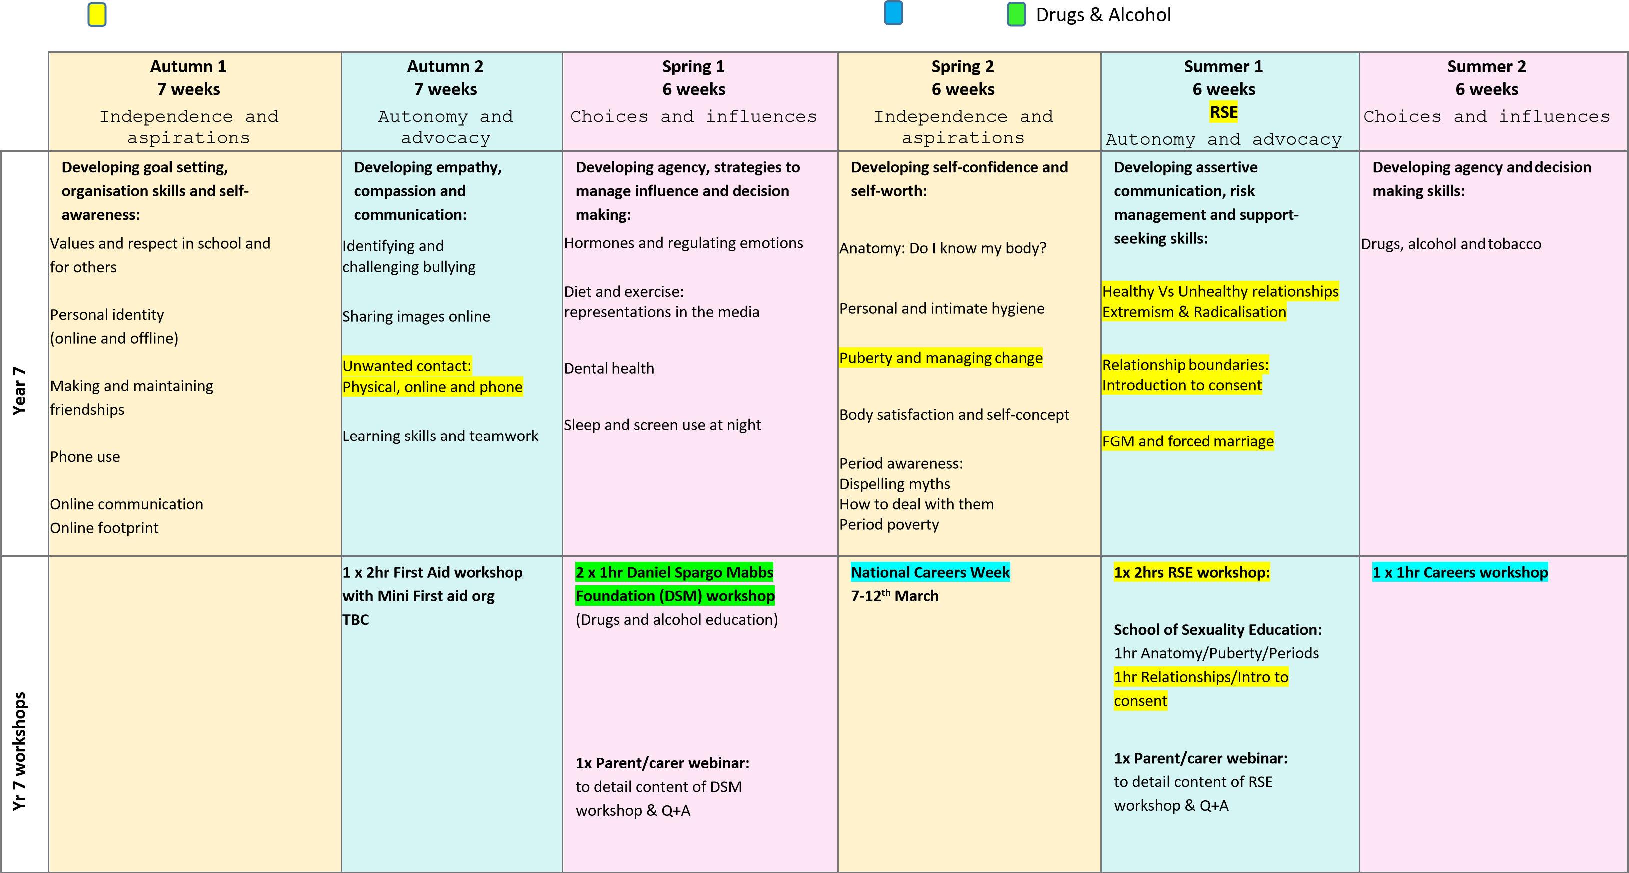 Sex education: Parents/carers have the right to withdraw their child from these lessons Careers
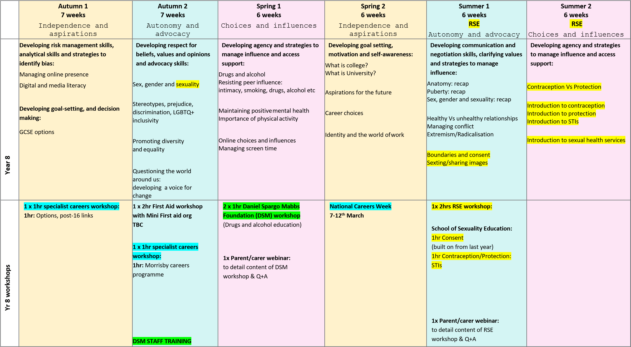
 | Autumn 1  7 weeks  Choices and influences | Autumn 2  7 weeks  Autonomy and advocacy | Spring 1  6 weeks  Independence and aspirations | Spring 2  6 weeks  Independence and aspirations | Summer 1  6 weeks  RSE  Autonomy and advocacy |  |  |  | Summer 2  6 weeks  RSE  Choices and influences
Year 9 | Developing empathy, compassion and strategies to access support:  Mental health: including self- harm and eating disorders  Change, loss and bereavement  Healthy coping strategies | Developing self-confidence, risk management and strategies to manage influence:  Drugs and alcohol  Assertive communication | Developing goal-setting, analytical skills and decision making:  Sources of careers advice:  Education expectations 16-18yrs  The path to College  The paths to apprenticeships  The paths to University  Studying abroad  Employability | Developing analytical skills and strategies to identify bias and manage influence:  Financial decisions:  Saving and borrowing  Gambling, financial choices and debt | Developing assertive communication, clarifying values and strategies to manage influence:  Anatomy: recap |  |  |  | Developing decision making, risk management and support-seeking skills:
 |  |  |  |  |  |  |  |  | Contraception Vs Protection: recap
 |  |  |  |  |  |  |  |  | Sexually transmitted infections
 |  |  |  |  | Consent and pleasure
 |  |  |  |  |  |  |  |  | Sex in the media
 |  |  |  |  | Relationships: |  |  |  | Pornography
 |  |  |  |  | Coercive control |  | challenges
Radicalisation Gangs
Friendship

Yr 9 workshops |  | 1 x 2hr First Aid workshop with Mini First aid org | 2 x 1hr Daniel Spargo Mabbs  Foundation (DSM) workshop  (Drugs and alcohol education)  1x Parent/carer webinar: to detail content of DSM workshop & Q+A  1 x 1hr specialist careers  workshop:  1hr: Employer encounter | National Careers Week  7-12th March  1x 2hrs RSE workshop:  School of Sexuality Education:  1hr Contraception/Protection:  STIs  (built on from last year)  1hr: TBC  1x Parent/carer webinar: to detail content of RSE workshop & Q+A

