Reigate School

Relationships and Sex Education Policy

Approved by: | Reigate School  Full Governing Board | Date: 30 November 2022
Last reviewed on: | 21st October 2022
Next review due by: | October 2023

Aims

The aims of relationships and sex education (RSE) at our school are to:
- Provide the pupils with age and developmentally appropriate information to help them develop healthy, nurturing relationships of all kinds, not just intimate relationships.
- Provide a framework in which sensitive and inclusive discussions can take place to help pupils understand the positive effects that good relationships have on their mental wellbeing, identify when relationships are not right and understand how situations can be managed.
- Guide pupils in managing their personal and social lives in a positive way
- Prepare pupils for puberty, and give them an understanding of sexual development and the importance of health and hygiene
- Help pupils develop feelings of self-respect, confidence and empathy
- Create a positive culture around issues of sexuality and relationships
- Provide pupils with the knowledge they need of the law
- Teach pupils the correct vocabulary to describe themselves and their bodies, develop resilience and character of pupils to guide them in becoming productive members of society.

The teaching of RSE will support our school community values of Respect, Friendship, Resilience, Curiosity and Kindness and be fully inclusive.

Statutory requirements

As a secondary academy school, we must provide RSE to all pupils as per section 34 of the Children and Social work Act 2017.

In teaching RSE, we are required by our funding agreements to have regard to guidance issued by the Secretary of State as outlined in section 403 of the Education Act 1996. In designing the curriculum, we have also considered the Equality Act (2010).

At Reigate School we teach RSE as set out in this policy.

Policy development

This policy has been developed in consultation with staff, pupils and parents. The consultation and policy development process involved the following steps:
- Review – Head of PSHE and SLT link pulled together all relevant information including relevant national and local guidance;

- Staff consultation – all school staff were given the opportunity to look at the policy and make recommendations;

- Parent/stakeholder consultation – parents and any interested parties were invited to attend a meeting about the policy where suggested lesson content was also shown, discussed and amended where appropriate to reflect our community;

- Pupil consultation – we investigated what exactly pupils want from their RSE;

- Ratification – once amendments were made, the policy was shared with our Full Governing Board and ratified.

Definition

RSE is about the emotional, social, physical and cultural development of pupils, and involves learning about what is acceptable and unacceptable behaviour in all types of relationships, understanding sexual health, contraception, sexuality, healthy lifestyles, diversity and personal identity.
RSE provides age and developmentally appropriate information to help all pupils develop healthy, nurturing relationships of all kinds, not just intimate relationships. RSE involves a combination of sharing information, and exploring issues and values in a respectful manner to the range of faiths and cultural beliefs in our community.

RSE is not about the promotion of sexual activity and does not encourage early sexual experimentation.
RSE teaches pupils to understand human sexuality and to respect themselves and others through building their maturity, confidence and self-esteem so they are equipped to make safe, informed and healthy choices as they progress through adult life.

Curriculum

Our curriculum, and a selection of resources, are set out as per Appendix 2, but these will be adapted in light of parent, student and staff feedback over time.

We have developed the curriculum in consultation with parents, pupils and staff, taking into account the age, needs and feelings of pupils. Lessons and resources have been created and adapted with our students in mind and follow suggestions, plans and advice provided by the PSHE Association and Sex Education Forum.

If pupils ask questions outside the scope of this policy, teachers will respond in an age and developmentally appropriate manner so they are fully informed and don’t seek answers online.

When planning and teaching RSE lessons, we will take into account the religious background of all pupils to ensure that the core content is appropriately handled.

Our timetabled RSE lessons are supplemented with Drop Down workshops, led by the School of Sexuality Education, to allow for meaningful discussion over an extended period of time.

For more information about our curriculum, see our curriculum map in Appendix 2.

Delivery of RSE

RSE is taught within the personal, social, health and economic (PSHE) education curriculum led by Louisa Smith and a dedicated team of staff volunteers.
Biological aspects of RSE are taught within the science curriculum, and other aspects are included in religious education (RE).
Drop down workshops are also be used as an opportunity for discussion and development.

Pupils also receive sex education sessions delivered by trained professionals to compliment our in-house curriculum. These workshops are led by the School of Sexuality Education and parents and carers are invited to join year-specific webinars to learn more about the content. These parent/carer webinars also allow opportunity for questions to be asked and answered.

RSE focuses on giving young people the information they need to help them develop healthy, nurturing relationships of all kinds including:
- Families
- Respectful relationships, including friendships
- Online and media
- Being safe
- Intimate and sexual relationships, including sexual health

For more information about our RSE curriculum, see Appendix 2.

These areas of learning are taught within the context of family life taking care to ensure that there is no stigmatisation of children based on their home circumstances (families can include single parent families, LGBT parents, families headed by grandparents, adoptive parents, foster parents/carers amongst other structures), along with reflecting sensitively that some children may have a different structure of support around them (for example: looked after children or young carers).

To fully support our SEN children we will take the following actions:
- Ensure that all children have access to the school curriculum and are fully included in all activities of the school in order to promote the highest levels of achievement;
- Help all children achieve to the best of their abilities, despite any difficulty or disability they may have;
- Ensure that teaching staff are aware of and sensitive to the needs of all children and teaching children in a way that is more appropriate to their needs;
- Help children to gain in confidence and improve their self-esteem;
- To work in partnership with parents/ carers, children and relevant external agencies in order to provide for children’s special educational needs and disabilities;
- To identify at the earliest opportunity all children that need special consideration to support their needs (whether these are educational, social, physical or emotional);
- To make suitable provision for children with SEN to fully develop their abilities, interests and aptitudes and gain maximum access to the curriculum;
- To promote self-worth and enthusiasm by encouraging independence at all ages
and ability levels;
- To give every child the entitlement to a sense of achievement.
- Provide opportunity for the School of Sexuality Education to work in a small group basis with children in advance of larger, group workshops

Roles and responsibilities

The Governing Board

Reigate School’s School Committee of Governors will approve the RSE Policy, and hold the headteacher to account for its implementation.

The Headteacher

The Headteacher is responsible for ensuring that RSE is taught consistently across the school, and for managing requests to withdraw pupils from [non-statutory/nonscience] components of RSE (see section 8).

Staff

RSE is taught within the personal, social, health and economic (PSHE) education curriculum led by Louisa Smith and a dedicated team of staff volunteers.

Staff are responsible for:
- Delivering RSE in a sensitive way
- Modelling positive attitudes to RSE
- Monitoring progress
- Responding to the needs of individual pupils
- Responding appropriately to pupils whose parents wish them to be withdrawn from the [non-statutory/non-science] components of RSE

Staff do not have the right to opt out of teaching RSE. Staff who have concerns about teaching RSE are encouraged to discuss this with the Headteacher.

7.4 Pupils

Pupils are expected to engage fully in RSE and, when discussing issues related to RSE, treat others with respect and sensitivity.

Parents’ right to withdraw

Whilst we would not recommend this, for concern that pupils might source information online, parents and carers have the right to withdraw their children from the [nonstatutory/non-science] components of sex education within RSE up to and until 3 terms before the child turns 16. After this point, if the child wishes to receive sex education rather than being withdrawn, the school will arrange this.

Requests for withdrawal should be put in writing using the form found in Appendix 1 of this policy and addressed to the Headteacher.

A copy of withdrawal requests will be placed in the pupil’s educational record. The Headteacher will discuss the request with parents and take appropriate action.

Alternative work will be given to pupils who are withdrawn from sex education.

Training

Staff are trained on the delivery of RSE as part of their induction and it is included in our continuing professional development calendar. Specialist training is provided to the Head of PSHE to ensure that the curriculum is in line with government policy and all up to date resources are accessible.

Staff training needs are met to include: safeguarding children, handling sensitive and controversial issues and confidentiality to ensure that teachers do not let their personal beliefs and attitudes influence their teaching of RSE.

The Headteacher may invite visitors from outside the school, such as school nurses or sexual health professionals, to provide support and training to staff teaching RSE.

Monitoring arrangements

The delivery of RSE is monitored by Matt Alexander as Headteacher, Chris Harvey as PSHE Department Line Manager, and Louisa Smith as Head of PSHE. Monitoring is an ongoing process that checks the degree to which our programme of study is being effectively implemented This monitoring will answer questions such as:

- Is the programme effectively managed and are staff clear about their roles and responsibilities?
- Does the planned programme reflect national guidance, local priorities and pupils’ needs?
- Are all pupils being taught the programme as planned?
- Is the quality of teaching consistent across all classes and does it exemplify best practice?

These questions can be answered through planning reviews, learning walks, stakeholder surveys, recording pupil attendance of RSE aspects of PSHE and drop down workshops, regular review of the RSE policy, gathering information school reports and sampling the quality and content of children's work.

Pupils’ development in RSE is monitored by class teachers as part of our internal assessment systems. Additionally, this is done through:

- Baseline testing at the start and end of each unit
- Lesson observations
- Parent, staff and student surveys

This policy will be reviewed by SLT annually. At every review, the policy will be approved by the School Committee of Governors.

Appendix 1: Parent form: withdrawal from sex education within RSE

TO BE COMPLETED BY PARENTS
Name of child |  | Class
Name of parent |  | Date
Reason for withdrawing from sex education within relationships and sex education
Any other information you would like the school to consider
Parent signature

TO BE COMPLETED BY THE SCHOOL
Agreed actions from discussion with parents

APPENDIX 2: LONG TERM OVERVIEW: Reigate School Lifeskills programme of study

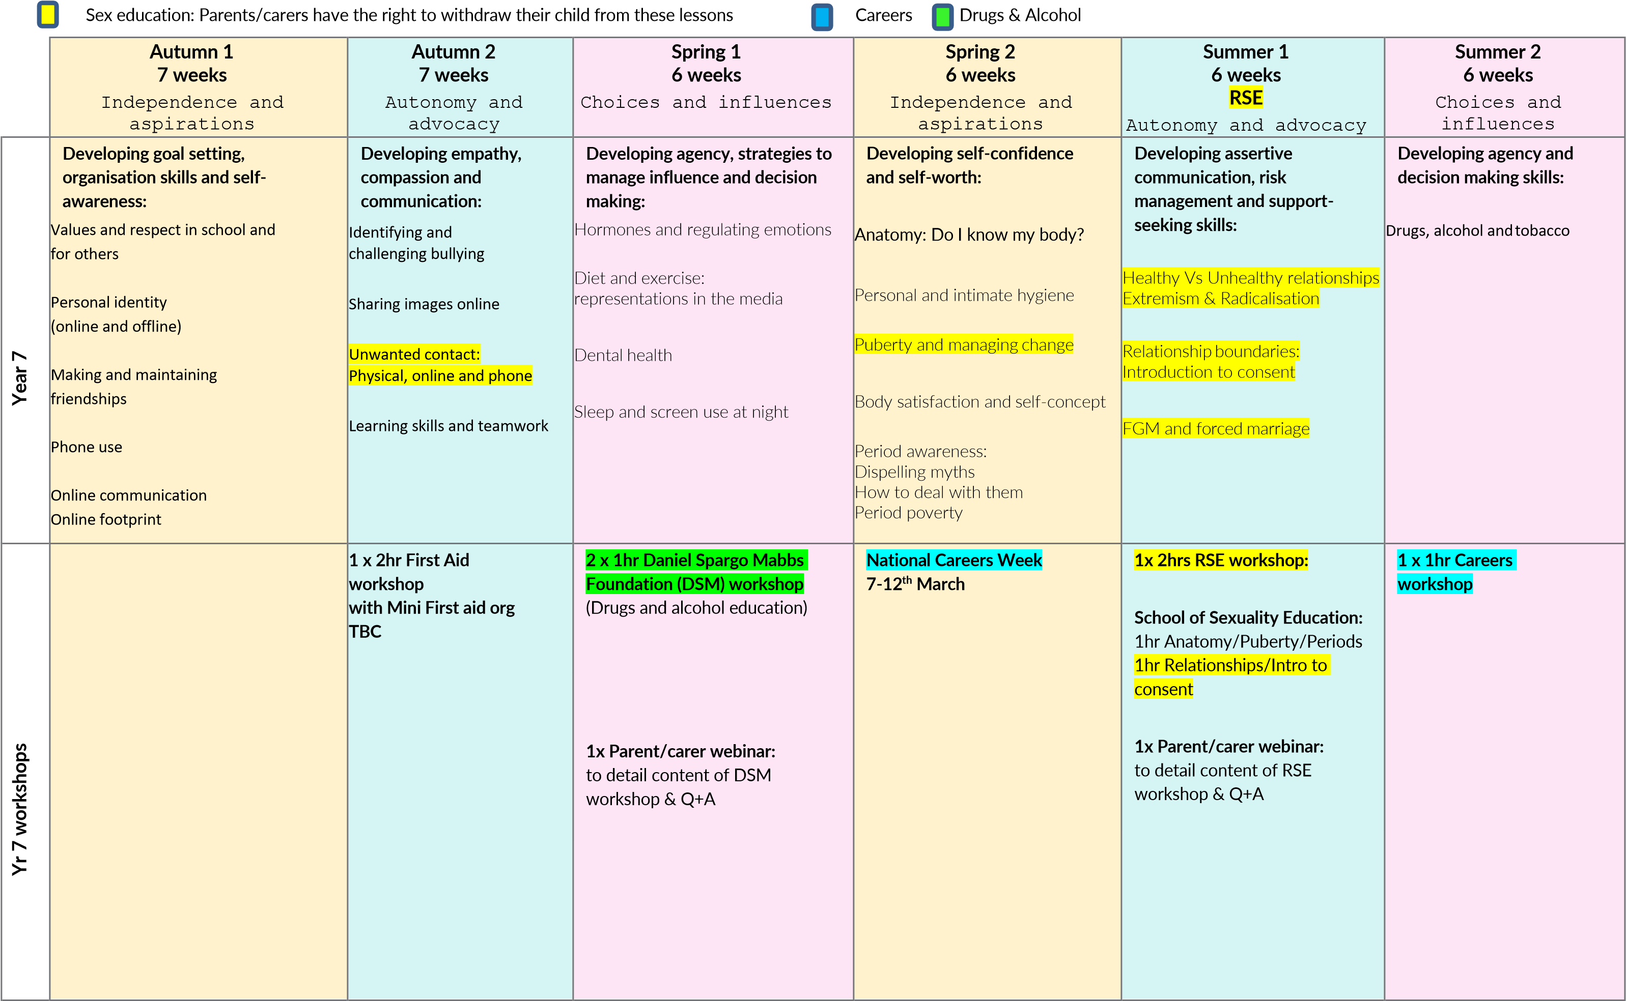
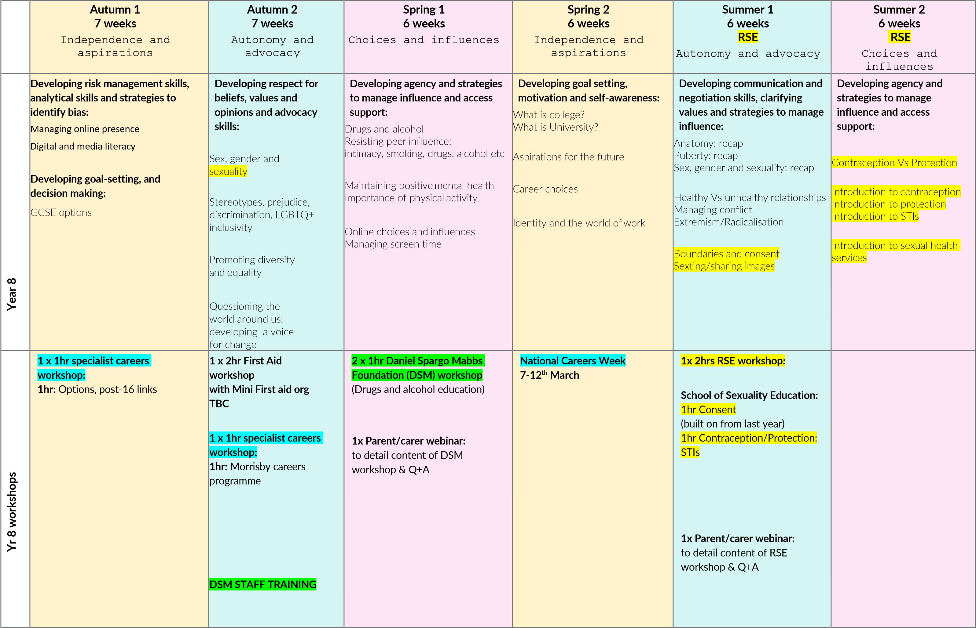
 | Autumn 1  7 weeks  Choices and influences | Autumn 2  7 weeks  Autonomy and advocacy | Spring 1  6 weeks  Independence and aspirations | Spring 2  6 weeks  Independence and aspirations | Summer  6 weeks  RSE  Autonomy and |  |  | 1  advocacy | Summer 2  6 weeks  RSE  Choices and influences
Year 9 | Developing empathy, compassion and strategies to access support:  Mental health: including self- harm and eating disorders  Change, loss and bereavement  Healthy coping strategies | Developing self-confidence, risk management and strategies to manage influence:  Drugs and alcohol  Assertive communication | Developing goal-setting, analytical skills and decision making:  Sources of careers advice:  Education expectations 16-18yrs  The path to College  The paths to apprenticeships  The paths to University  Studying abroad  Employability | Developing analytical skills and strategies to identify bias and manage influence:  Financial decisions:  Saving and borrowing  Gambling, financial choices and debt | Developing asserti communication, cla values and strategi influence:  Anatomy: recap |  |  | ve  rifying  es to manage | Developing decision making, risk management and support-seeking skills:
 |  |  |  |  |  |  |  |  | Contraception Vs Protection:
 |  |  |  |  |  |  |  |  | recap
 |  |  |  |  | Consent and pleasure |  |  |  | Sexually transmitted infections
 |  |  |  |  | Relationships: |  |  |  | Sex in the media
 |  |  |  |  | Coercive control |  | s |  | Pornography
Radicalisation
Gangs
Friendship challenge

Yr 9 workshops |  | 1 x 2hr First Aid workshop  with Mini First aid org | 2 x 1hr Daniel Spargo Mabbs  Foundation (DSM) workshop  (Drugs and alcohol education)  1x Parent/carer webinar: to detail content of DSM workshop & Q+A  1 x 1hr specialist careers  workshop:  1hr: Employer encounter | National Careers Week  7-12th March  1x 2hrs RSE workshop:  School of Sexuality Education:  1hr Contraception/Protection:  STIs  (built on from last year)  1hr: TBC  1x Parent/carer webinar: to detail content of RSE workshop & Q+A

